**Approach, design, & algorithm**

Before starting this assignment I took some time to look through all the provided documentation to get a full grasp of the expectations and objectives. I also took some time to review my notes on the textbook’s linked list implementation using a head and tail reference. Then I sat down and wrote the pseudocode for the more complicated methods within the BasicDoubleLinkedList class. After writing my main methods I had to do some tweaking to ensure everything executed according to the specifications provided. Once I was done debugging the partial code I had created, I moved on to defining the easier methods, those being all the methods except the iterator method. These methods were pretty straight forward so I was able to get them done without too much suffering.

I then focused my attention on the list iterator which seemed confusing at first. I began by writing some initial code that did not work as expected. Then, I tested this code, looked at where my algorithm fell short and adjusted my code accordingly. It took a few trials and design iterations to get the right algorithm going but luckily it wasn’t as hard as I thought it would be.

The add method for the SortedDoubleLinkedList class did take me a while to figure out. I ended up using write an initial design on paper, a picture of which is included at the end in the section titled “Additional Insight into my planning/design.” If you take a look at this initial design, you can probably notice that it was far from perfect. Therefore, I went through multiple design iterations to tweak it to perfection. This admittedly took much longer than I would have liked. Hence, I will try to make time in the future to practice with sorted collections.

**What did you learn?**

I definitely had to go out and research what a comparator was. I had never encountered this object type before this object. However, I am still not completely convinced of its merit. The comparators we used in this project simply call the object’s compareTo method. Therefore, I am confused why the comparator object is even necessary. To me, it feels like it takes up extra space and adds additional complexity for little to no benefit. Also, it seems completely contrary to the idea that an object should have private data and provide public operations on said data. The comparator seems like an instantiable utility class, something that I see no true use case for given what we have discussed in the past and thus far in CMSC 207. This is not to say that the comparator object is completely useless but rather I just don’t comprehend why someone would ever want to use it over a simpler compareTo method implementation.

**What issues did you encounter, if any?**

As alluded to in the previous section, the comparator object did confuse me and required some research to fully grasp and understand.

The add method for the SortedDoubleLinkedList class definitely stumbled me but I was eventually able to find my way through it.

I was also confused by the protected declarations specified in the project documentation. I have included more information on this issue in the Questions section.

**What would you have done differently?**

If I had more time I would have finished the ListIterator implementation and refined my code as much as possible.

**Questions**

We were told to specify the members of the BasicDoubleLinkedList class as protected. However, since everything in my project is contained within one default package that would mean all classes in the project would have access to it’s data fields. Does this mean I should specify the BasicDoubleLinkedList class in it’s own package so that only the subclass can access it’s members? Is that a good coding convention or is there a different more optimal methodology?

if I do define it in its own package I would have to modify all instructor code, and my code for that matter, to include a package import statement. Thus, since these projects are generally strict on not modifying instructor code I will not try to resolve this security issue. However, this is a problem that I have yet to encounter in my java programming journey. Therefore, I will likely search for a valid solution to this issue on my own time if possible.

Along the same line of questioning, how does the inheritance of private inner classes work? If I specify the inner class as protected will it then be accessible by subclasses? Of course, this creates the same security issue mentioned before because then all classes in the default package will have access to the class

Again, along the same line of questioning, if I make Node a protected inner class of BasicDoubleLinkedList and the fields of Node private the subclass will not have access to those fields. Therefore, I could either create set and get methods for each field but this would create the same security issues mentioned earlier. Also, creating protected set and get methods would be no different than providing protected access to Node’s fields. I do not think what I am doing here is at all conventional as it goes against the principles of data hiding/security for objects. However, as mentioned earlier creating a new package would require modifying the instructor code. Therefore, to avoid those edits I will ignore these security flaws.

**Assumptions**

I did not make any significant or special assumptions during this project.

**Test Cases GUI**

**sorted list:**

case: add “broccoli”

expected: the word to be added

result: as expected

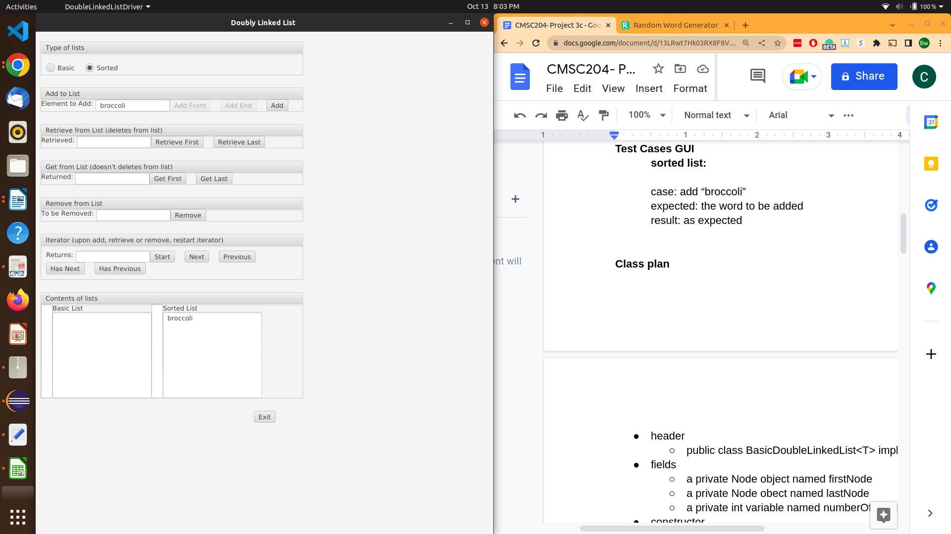

case: add “program”

expected: “program” to be added after “broccoli”

result: as expected

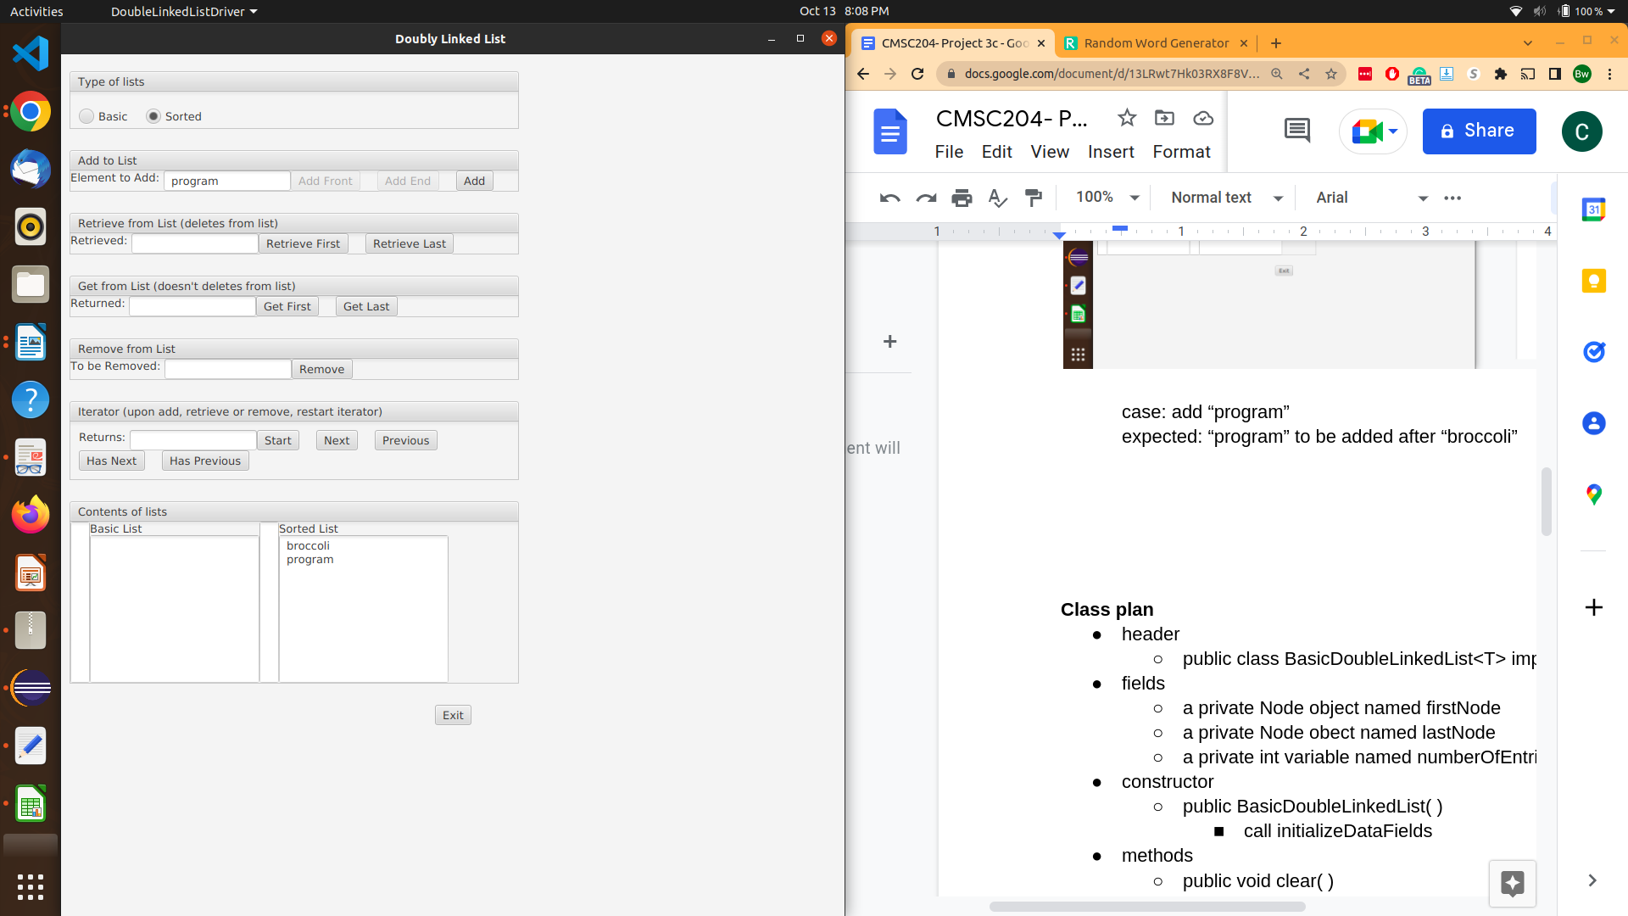

case: get first

expected: broccoli

result: as expected



case: get last

expected: program

result: as expected

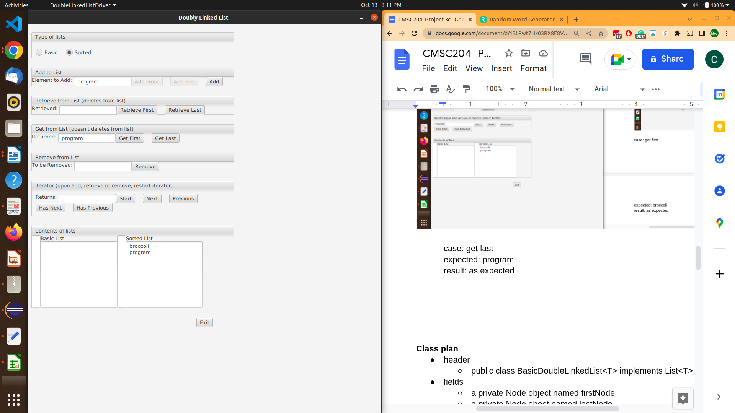

case: add affair

expected: affair to be placed at the front of the list before broccoli

result: as expected

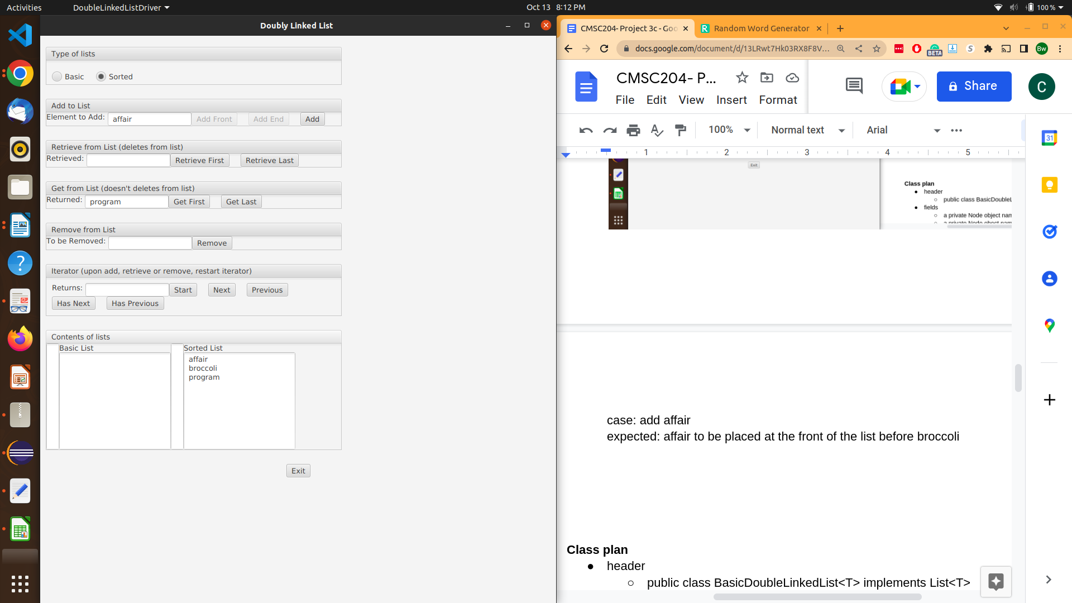

case: retrieve first

expected: affair to be returned and removed

result: as expected



case: remove program

expected: program to be removed

result: as expceted



case: remove chris

expected: nothing should happen because null should be returned

result: as expected

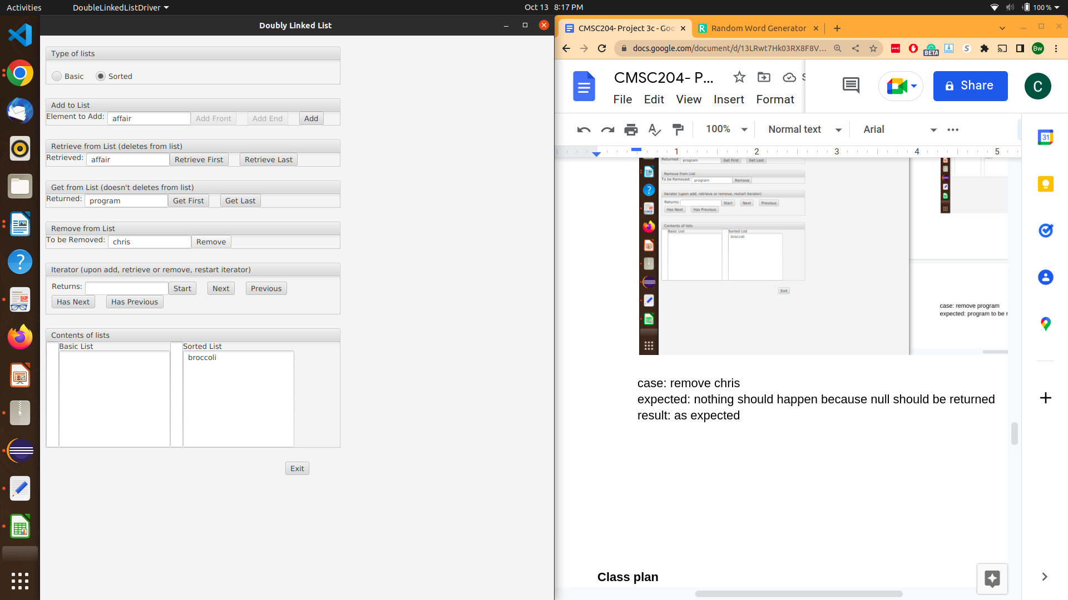

case: retrieve last

expected: broccoli to be removed and returned

result: as expected



**basic list:**

case: add “meadow” to front

expected: “meadow” to appear as the only item in the list

result: as expected



case: add “hair” at the front

expected: hair to be added before meadow

result: as expected



case: add “motif” to end

expected: “motif” to be added at the end after meadow

result: as expected

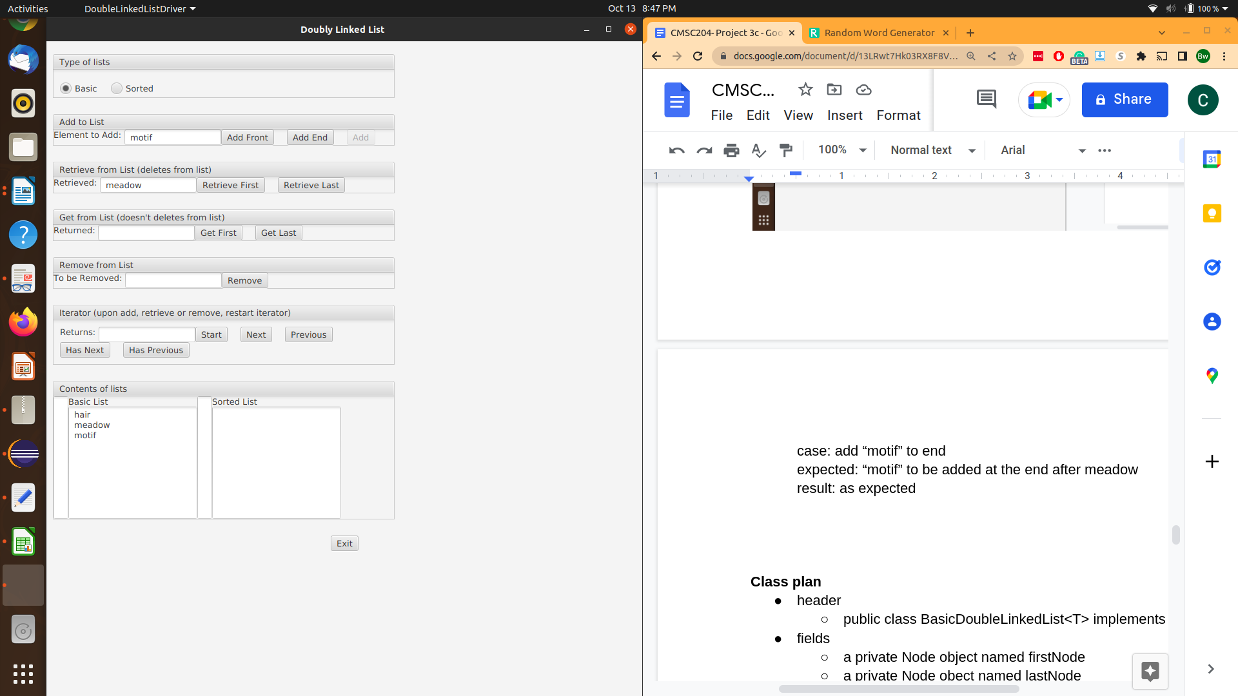

case: add “offer” to the front

expected: “offer” to be added in front of hair

result: as expected



case: start iterator check has previous

expected: false to be returned

result: as expected

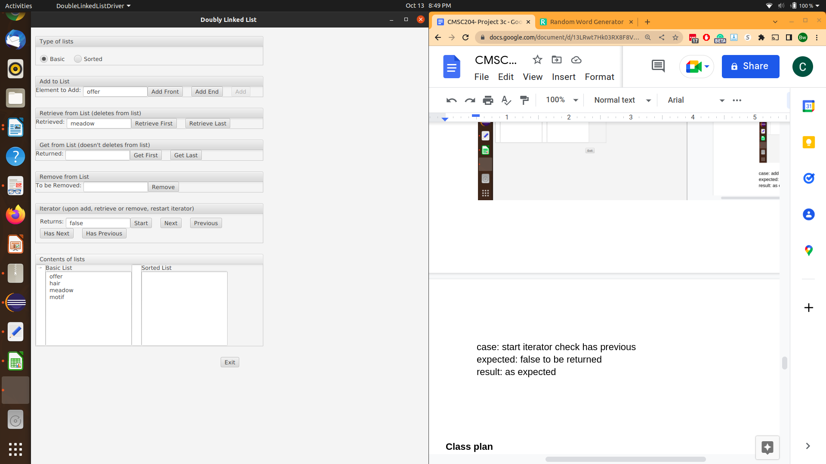

case: retrieve previous entry

expected: an exception to be thrown because there is no previous entry

result: as expected



case: call next

expected: offer to be returned

result: as expected

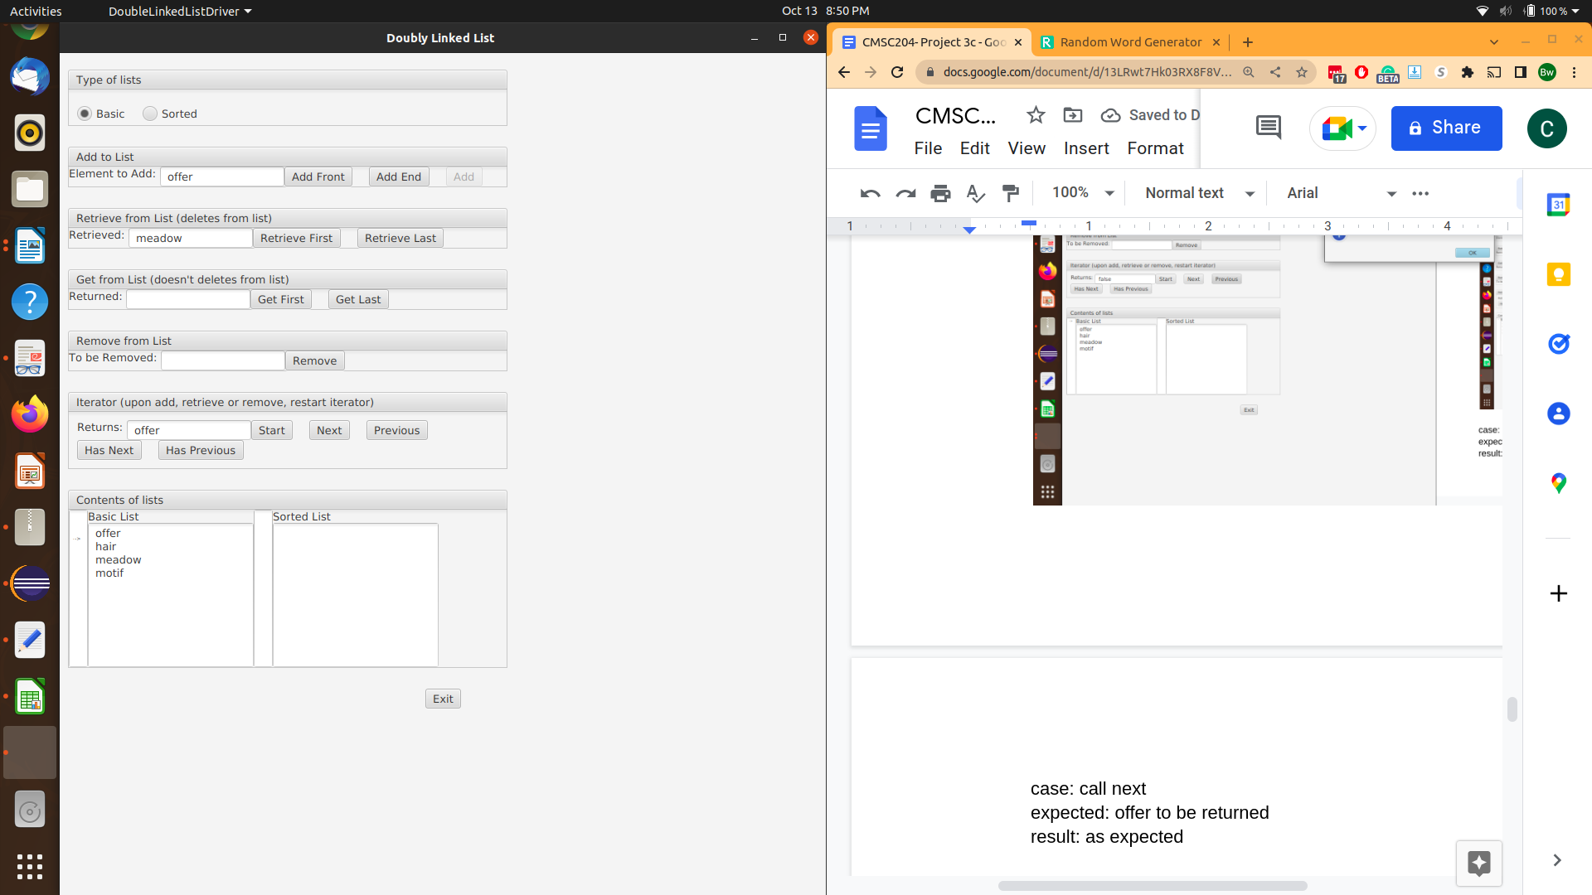

case: check hasPrevious

expected: true

result: as expected



case: call next

expected: hair to be returned

result: as expected



case: call next

expected: meadow to be returned

result: as expected



case: call next

expected: motif to be returned

result: as expected

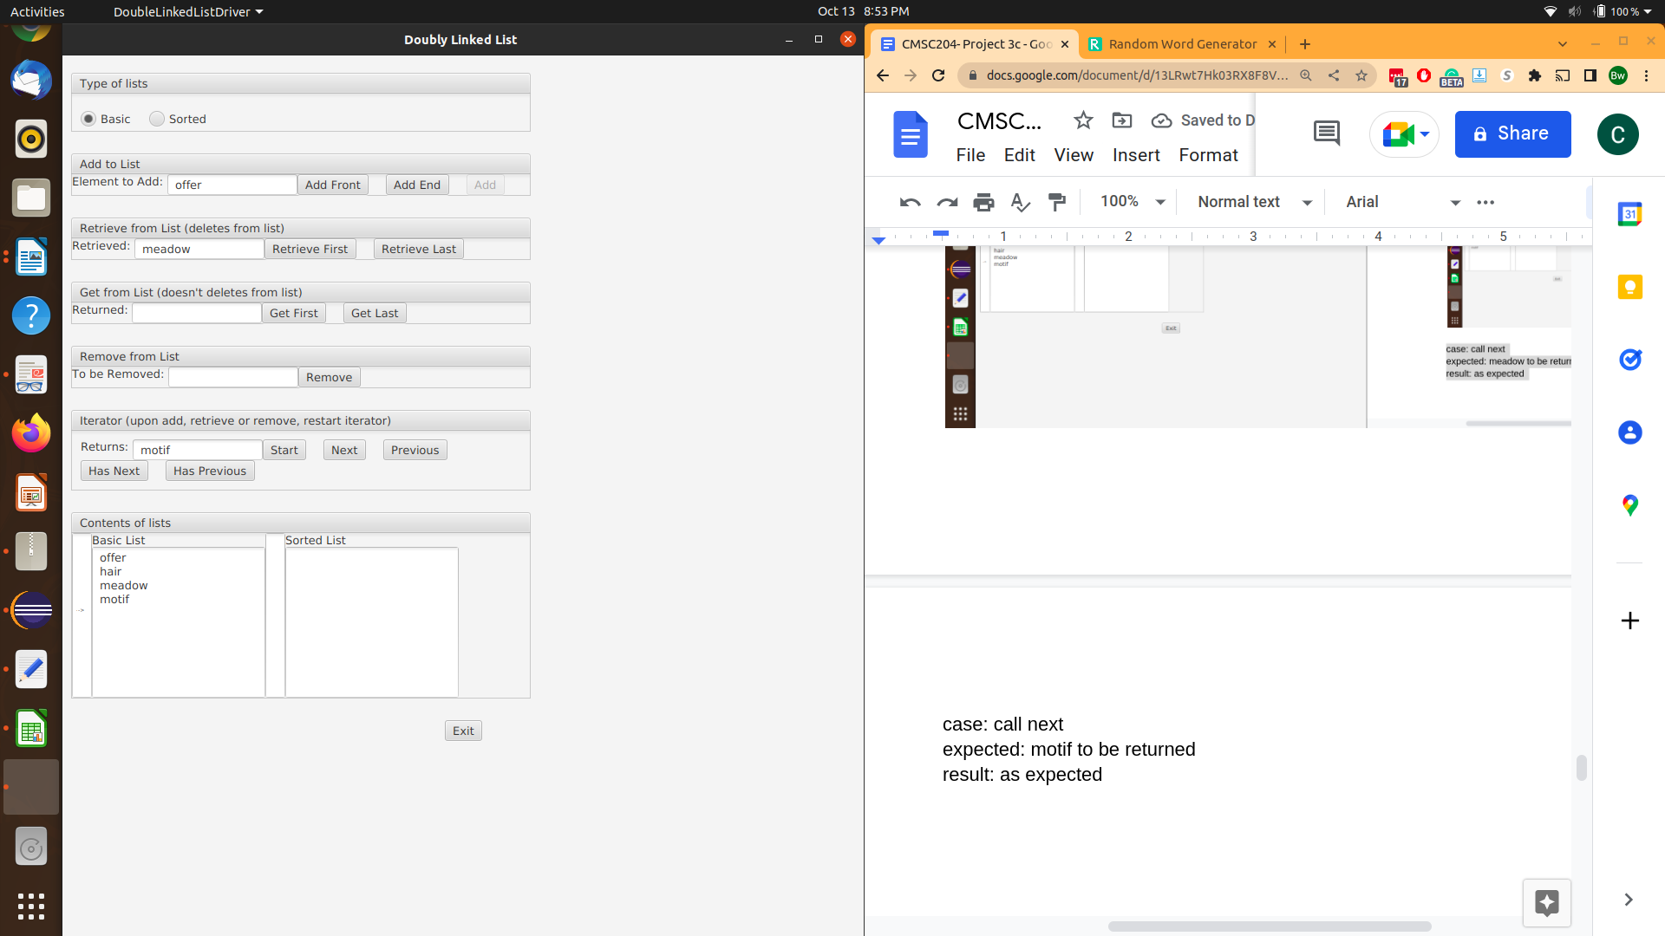

case: check has next

expected: false

result: as expected



case: call next

expected: exception because there is no next entry

result: as expected



case: remove meadow

expected: meadow to be removed

result: as expected



case: remove hair

expected: hair to be removed

result: as expected

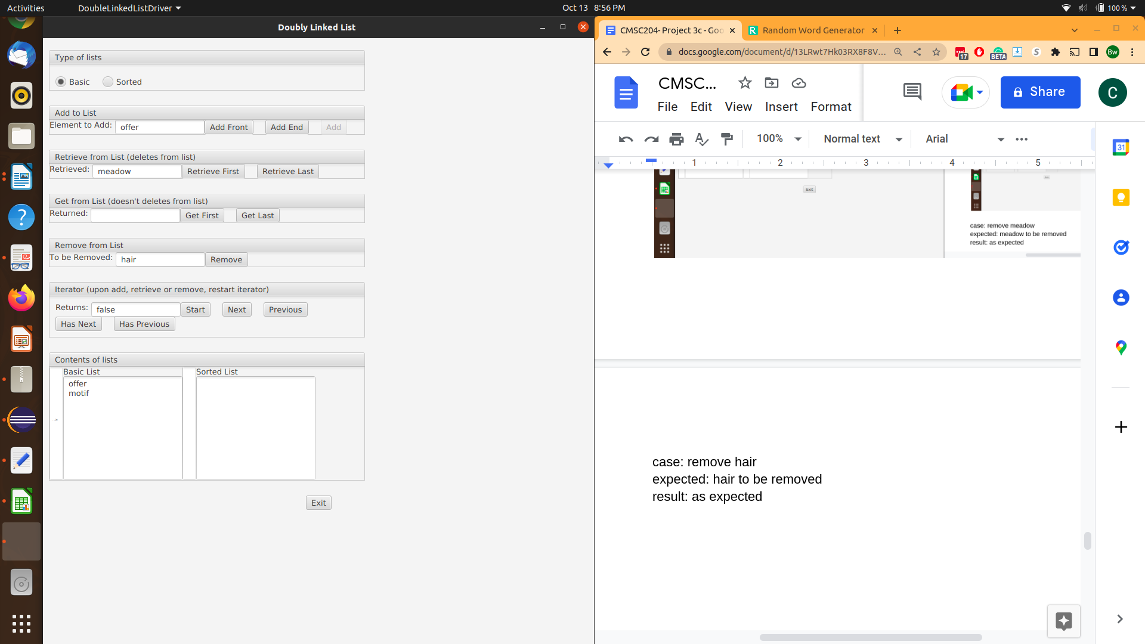

case: retrieve last

expected: motif to be removed and returned

result: as expected



case: retrieve first

expected: offer to be removed and returned

result: as expected



**JUnit test screenshots**

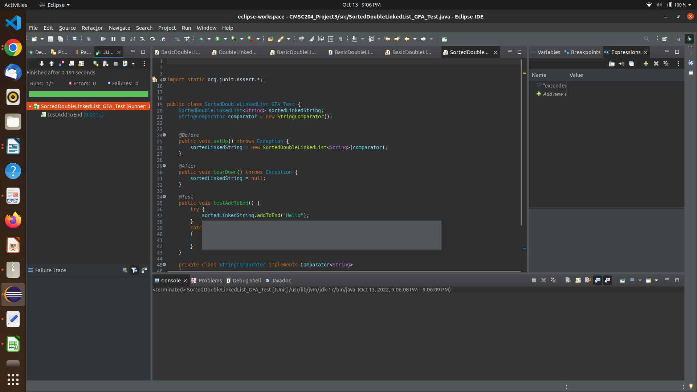

**Additional Insight into my planning/design**

* working out the add method for SortedDoubleLinkedList on paper
  + 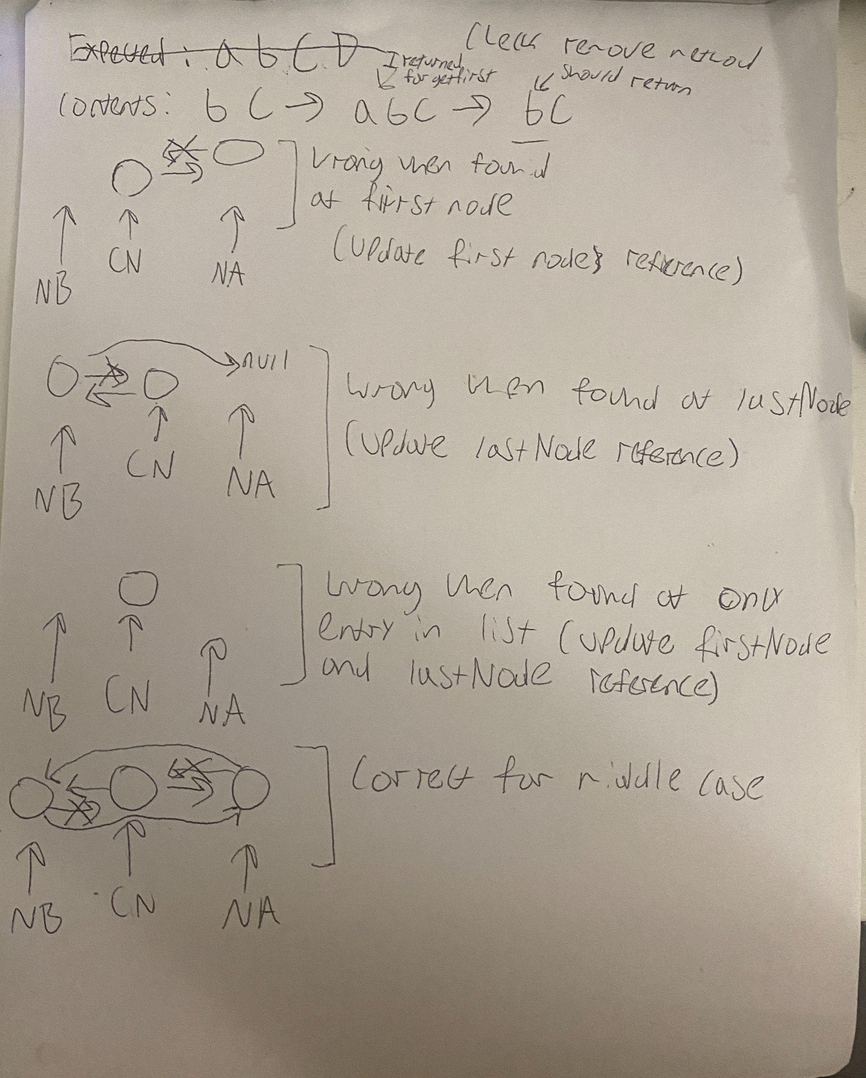
* BasicDoubleLinkedList class plan
* header
  + public class BasicDoubleLinkedList<T> implements List<T>
* fields
  + a private Node object named firstNode
  + a private Node obect named lastNode
  + a private int variable named numberOfEntries
* constructor
  + public BasicDoubleLinkedList( )
    - call initializeDataFields
* methods
  + public void clear( )
    - call initializeDataFields
  + private void initializeDataFields( )
    - set firstNode to null
    - set lastNode to null
    - set numberOfEntries to -1
  + private Node getNodeAt(int givenPosition)
    - create a new Node reference variable named currentNode
    - if givenPosition is equal to numberOfEntries //if node requested is the last node
      * pass currentNode the reference stored in lastNode
    - end if
    - else //anything other than the last node
      * pass currentNode the reference to firstNode
      * for int count equals 0 to count less than givenPosition incrementing count after each iteration
        + pass currentNode the reference stored in currentNode’s next field
    - end else
    - return the reference stored in current node
  + public void add(int givenPosition, T newEntry)
    - if (givenPosition is greater than or equal to 0) AND (givenPosition is less than or equal to numberOfEntries + 1)
      * create a new Node reference varibale named newNode and pass it a reference to a new Node object containg newEntry
      * if the list is empty //if the given position is valid and the list is empty
        + pass firstNode the reference to newNode
        + pass lastNode the reference to newNode
      * else if givenPosition is 0 //chain must also not be empty b/c we just caught that with previous if statement
        + pass newNode’s next field the reference stored in firstNode
        + pass firstNode’s previous field the reference to newNode
        + pass firstNode a reference to newNode
      * else if givenPosition equals (numberOfEntries + 1) //if addition is at the end of the chain
        + pass lastNode’s next field a reference to newNode
        + pass newNode’s previous field a reference to lastNode
        + make lastNode reference newNode
      * else //addition occurs anywhere else in a non empty chain
        + create a new Node reference variable named nodeBefore and pass it the return from calling getNodeAt(givenPosition minus 1)
        + create a new Node reference variable named nodeAfter and pass it the reference stored in nodeBefore’s next field
        + pass newNode’s next field a reference to nodeAfter
        + pass nodeAfter’s previous field a reference to newNode
        + pass nodeBefore’s next field a reference to newNode
        + pass newNode’s previous field a reference to nodeBefore
      * increment numberOfEntries
    - else //if given position is invalid
      * throw an IndexOutOfBoundsException
  + public void add(T newEntry)
    - create a new Node reference variable named newNode and pass it the reference to a new Node object containing newEntry
    - if the list is empty
      * pass firstNode a reference to newNode
    - else //list is NOT empty
      * pass lastNode’s next field a reference to newNode
      * pass newNode’s previous field a reference to lastNode
    - pass lastNode a reference to newNode [that is make the lastNode field reference newNode which is now the new end of the chain]
    - increment numberOfEntries
  + public boolean isEmpty( )
    - declare a boolean variable named result
    - if numberOfEntries is -1
      * set result to true
    - otherwise
      * set result to false
    - return result
* private class Node
  + fields
    - a Node reference variable named next
    - a T reference variable named data
    - a Node reference variable named previous
  + constructors
    - public Node(Node nextField, T dataField, Node previousField)
      * pass next the reference stored in nextField
      * pass data the reference stored in dataField
      * pass previous the reference stored in previousField